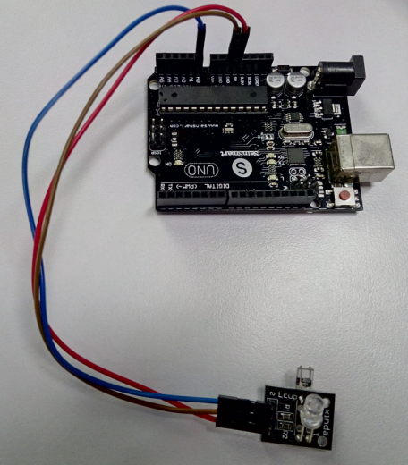

// Pulse Monitor Test Script

int ledPin = 13;

int sensorPin = 0;

double alpha = 0.75;

int period = 20;

double change = 0.0;

void setup()

{

pinMode(ledPin, OUTPUT);

Serial.begin(115200);

}

void loop()

{

static double oldValue = 0;

static double oldChange = 0;

int rawValue = analogRead(sensorPin);

double value = alpha \* oldValue + (1 - alpha) \* rawValue;

Serial.print(rawValue);

Serial.print(",");

Serial.println(value);

oldValue = value;

delay(period);

}